DAT601 Assessment

Ole HochbrUEgge

2024

Contents

An introduction to data modelling in information systems 3

Description of conceptual modelling. A depiction and description of all components of a Chen ERD. 4

A conceptual ER model using Chen Enhanced ERD notation 6

Data dictionary 7

Assumptions made about the business rules and the reasons for the choices 1

Milestone Two 2

Conceptual to Relational Logical model 2

NaLER Analysis 3

Source 4

## An introduction to data modelling in information systems

Developing information systems that efficiently gather, handle, and use data, require Data Modelling. It consists of creating physical, logical, and conceptual representations of connections and data structures inside an organisation. The key ideas that ensure data accuracy, consistency, integrity, and accessibility throughout time are the foundation of effective data management.

Fundamental Principles of Effective Data Management found on(*What Is an Entity Relationship Diagram (ERD)?*, n.d.):

1. **Data Quality**: Making sure that data is relevant, accurate, thorough, and consistent with the requirements of a business is of the highest significance. To guarantee that mistakes are kept to a minimum and that strict standards are maintained, regular usage of data quality measures is required.
2. **Data Governance**: Data governance is the action of creating policies, procedures, and positions for the management of data resources inside an organisation. This method ensures accountability, compliance with regulations, and strategic alignment with corporate objectives.
3. **Data Security**: There are safeguards in place to prevent illegal data from being accessed, altered, or disclosed. These include implementing use restrictions, limiting access to only authorised staff via authentication, and conducting regular security audits to guarantee the preservation of sensitive data.
4. **Data Integration**: Ensure that data is flowing smoothly between the various systems and applications used by the company. Through integration, discrete information pockets are removed, ensuring data consistency and enhancing decision-making abilities.
5. **Data Lifecycle Management**: The systematic approach from development to archiving or removal is called Data Management. This involves developing procedures for gathering, storing, retrieving, archiving, and destroying data while considering legal and regulatory requirements.
6. **Metadata Management**: Metadata documentation and upkeep provide context and meaning to data. The ability to interact with learning and interpretation of data are all enhanced by metadata management.

An Overview of Data Modeling (*What Is Data Modeling?*, 2024):

1. **Conceptual Data Modeling**: Understanding business needs, creating overarching concepts, and creating relationships between different data components are the main focus points throughout this phase. To make the data structure understandable for non-technical people, conceptual models are usually used.
2. **Logical Data Modeling**: Now the Conceptual model has been further developed into a more detailed diagram with components like relationships, keys, and data properties. Logical models of data show their structure independently of database systems; they are mostly used to define database schemas as they are represented graphically by Entity-Relationship Diagrams or the Unified Modelling Language (UML).
3. **Physical Implementation**: The conceptual data model must finally be transformed into a physical database structure that is compatible with the selected database management system. To do this, tables and columns must be created, data types must be specified, indexes must be established, and restrictions must be based on efficiency, storage capacity, and security standards. The physical design's implementation gives a quick and easy way to manipulate data while providing an effective way to store or retrieve it.

## Description of conceptual modelling. A depiction and description of all components of a Chen ERD.

(*How To Make Chen ER Diagram | Entity Relationship Diagram - ERD - Software for Design Chen ER Diagrams | ERD Symbols and Meanings | What Is Chen Notation*, n.d.)

The underlying idea of the Enhanced Chen ERD is to represent entities, attributes, relationships, and cardinality restrictions using a variety of symbols and notations. While attributes are used to show different aspects, like an order date or a customer's name, entities stand for things or concepts that exist in the real world, such as customers, items, or orders. There is another improvement in the system that involves weak entities. These are entities without unique identification through their attributes; they require a strong entity for adequate recognition. Weak entities appear as double-bordered rectangles in diagrams, indicating reliance on other related entities for existence.

A comprehensive conceptual modelling framework that takes into account subtypes, weak entities, and participation limits is provided by the Enhanced Chen ERD. Using this technique helps stakeholders better understand the relationships and structure found in a database, allowing the database to be better designed with reliable solutions that work well.

(*ER Diagrams in DBMS*, n.d.)

**Components of Chen's Entity-Relationship Diagram:**  
Attributes are characteristics of an entity and are depicted by Ovals connected to an entity. The primary key is different from other attributes because it uniquely distinguishes each entry within a table. When creating Chen Entity-Relationship Diagrams, the primary key is highlighted by underlining its attribute oval. Associations between entities are represented by relationships, which show their connections and interactions. Chen ERDs utilizes diamond shapes connected using lines to the related entities. Every relationship is given a descriptive name. In Chen ERDs, symbols placed near or on the lines representing relationships are used to indicate cardinality. The notations frequently employed for indicating cardinality include "1" (one), "M" (many), and "0"(zero). An instance where there is one entity associated with multiple instances from another would be denoted as “1:M” within this system.  
  
**Extended Elements of Chen's ERD:**  
Weak entities lack their own primary key attribute and thus depend on a related strong entity to furnish a partial or complete identifier. These types of entities are depicted by dual rectangles in Chen ERDs and linked to their identifying strong entities through a double-diamond relationship.  
Derived attributes are those that may be obtained from other attributes that are part of the same entity. These attributes are computed or produced based on requirements rather than being explicitly stored. A dashed oval in Chen ERDs denotes derived qualities, such as age.  
Multivalued attributes refer to the characteristic of having more than one value for a singular instance of an entity. They are visually represented using twin ovals in Chen ERDs.

1. Composite Attributes

Description: Composite attributes can be broken down into smaller parts. For example, an attribute like "Address" might consist of "Street," "City," and "Zip Code." Depiction: Represented as an oval connected to smaller ovals.

2. Weak Entities

Description: Weak entities can’t be uniquely identified by their attributes alone and rely on a “strong”/”normal” entity and have a partial key. Depiction: Represented as a double rectangle.

## A conceptual ER model using Chen Enhanced ERD notation

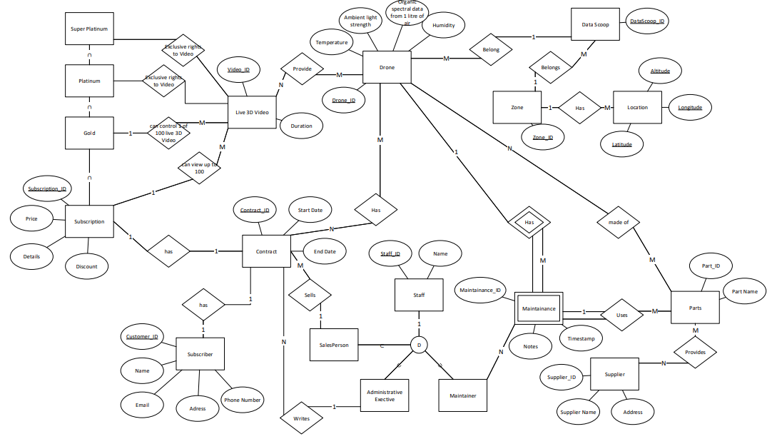

## Data dictionary

**Table 1: Document Entities**

|  |  |  |  |
| --- | --- | --- | --- |
| **Entity Name** | **Description** | **Aliases** | **Occurrence** |
| datascoop | A collection of live 3d video | DataScoop |  |
| live3dvideo |  | Live 3D Video |  |
| zone |  | Zone |  |
| subscriber |  | Subscriber |  |
| contract |  | Contact |  |
| maintenance |  | Maintenance |  |
| supplier |  | Supplier |  |
| administrative_executive |  | Administrative Executive |  |
| drone | Records Live 3D Video | Drone |  |
| subscription |  | Standard |  |
| location |  | Location |  |

**Table 2: Document Relationships**

|  |  |  |  |  |  |  |
| --- | --- | --- | --- | --- | --- | --- |
| **Entity Name** | **Cardinality** | **Participation** | **Relationship** | **Participation** | **Cardinality** | **Entity Name** |
| Drone | 1 | Optional | Has (identifying) | Mandatory | M | Maintenance (weak) |
| Drone | N | Optional | Has | Optional | M | Contract |
| Zone | 1 | Optional | has | Optional | M | Location |
| DataScoop | M | Optional | belongs | Optional | 1 | Zone |
| Zone | 1 | Optional | Belongs | Optional | M | Contract |
| Subscriber | 1 | Optional | Has | Optional | 1 | Contract |
| Contract | 1 | Optional | Has | Optional | 1 | Subscription |
| Administrative Executive | 1 | Optional | Writes | Optional | N | Contract |

**Table 3: Document Attributes**

| **Entity Name** | **Attributes** | **Description** | **Domain** | **Aliases** | **Composite** | **Derived** | **Nulls** | **Key?** | **Default Value** |
| --- | --- | --- | --- | --- | --- | --- | --- | --- | --- |
| **Drone** | Drone_ID  Humidity  Temperature  Ambient Light strength  Organic spectral data from 1 litre of air | Remote data sensing capability (latitude, longitude, altitude) |  |  |  |  | No | Yes |  |
|  | Data storage capacity (one month onboard) |  |  |  |  |  |
|  | Sensing parameters (temperature, humidity, ambient light, organic spectral data) |  |  |  |  |  |
|  | Communication methods (satellite, ground-based mobile cellular networks) |  |  |  |  |  |
|  | Configuration options (Jungle, Forest, Savannahs, Ice and Snow, Mountain, Desert, Urban) |  |  |  |  |  |
| **Contract** | Contact_ID  Start_Date  End_Date | Subscription services provided |  |  |  |  | No | Yes |  |
|  | Subscription tiers (Standard, Gold, Platinum, Super Platinum) |  |  |  |  |  |
|  | Access rights (Platinum, Super Platinum exclusivity) |  |  |  |  |  |
|  | Geographic deployment (specified bounded regions/Zones) |  |  |  |  |  |
|  | Overlapping regional Zones |  |  |  |  |  |
| **Subscriber** | Customer_ID  Name  Email  Phone Number  Address | Subscription type (Standard, Gold, Platinum, Super Platinum) |  |  |  |  | No | Yes |  |
|  | Access to 3D stereographic video streams |  |  |  |  |  |
|  | Control interface for DataScoops |  |  |  |  |  |
|  |  |  |  |  |  |
| **Maintenance** | Maintenance_ID  Notes  Timestamp | Maintenance history |  |  |  |  | Yes | Yes |  |
|  | Parts maintenance schedule (every five years) |  |  |  |  |  |
|  |  |  |  |  |  |  |
| **Staff** | Staff_ID  Name | Administrative Executive role |  |  |  |  | No | Yes |  |
|  | Permission to change subscription prices |  |  |  |  |  |
|  | Permission to enter contract details |  |  |  |  |  |
| **Zones** | Zone_ID | Deployment of DataScoops |  |  |  |  | No | Yes |  |
|  | Overlapping regions |  |  |  |  |  |
|  | Potential sharing of Zones for remote roaming expansion |  |  |  |  |  |
| **Location** | Altitude  Longitude  Latitude | The combination of all three attributes make up the location |  |  |  |  | No | Yes |  |

## Assumptions made about the business rules and the reasons for the choices

An assumption made is that Zones potentially can overlap with one another.

The assumption that maintenance is going to be done by only one maintainer

# Milestone Two

## Conceptual to Relational Logical model

(*Conceptual to Relational*, n.d.)

To Create a logical model from a Conceptual model composite attributes become two or more attributes and simple ones stay the same. Unique identifiers might become primary keys

## NaLER Analysis

-Simple attributes become columns in the table.

-Composite attributes are broken down into simple attributes.

-If an entity only has a single unique identifier, it automatically becomes the primary key.

-A Many-to-Meany relationship is broken up by a new table with the foreign keys from both participating tables.

# Source

*Conceptual to Relational*. (n.d.). Retrieved 31 May 2024, from https://docs.google.com/presentation/d/1GIpYmyxIb0D43HKZee185aT2mTJrEuQbcpUaGpBm0sU

*ER Diagrams in DBMS: Entity Relationship Diagram Model | Simplilearn*. (n.d.). Simplilearn.Com. Retrieved 1 May 2024, from https://www.simplilearn.com/tutorials/sql-tutorial/er-diagram-in-dbms

*How To Make Chen ER Diagram | Entity Relationship Diagram—ERD - Software for Design Chen ER Diagrams | ERD Symbols and Meanings | What Is Chen Notation*. (n.d.). Https://Www.Conceptdraw.Com. Retrieved 1 May 2024, from https://www.conceptdraw.com/examples/what-is-chen-notation

*What is an Entity Relationship Diagram (ERD)?* (n.d.). Lucidchart. Retrieved 1 May 2024, from https://www.lucidchart.com/pages/er-diagrams

*What Is Data Modeling? | IBM*. (2024, March 26). https://www.ibm.com/topics/data-modeling